CALL FOR SUBMISSIONS:
Community engagement for inclusive rural transformation and gender equality
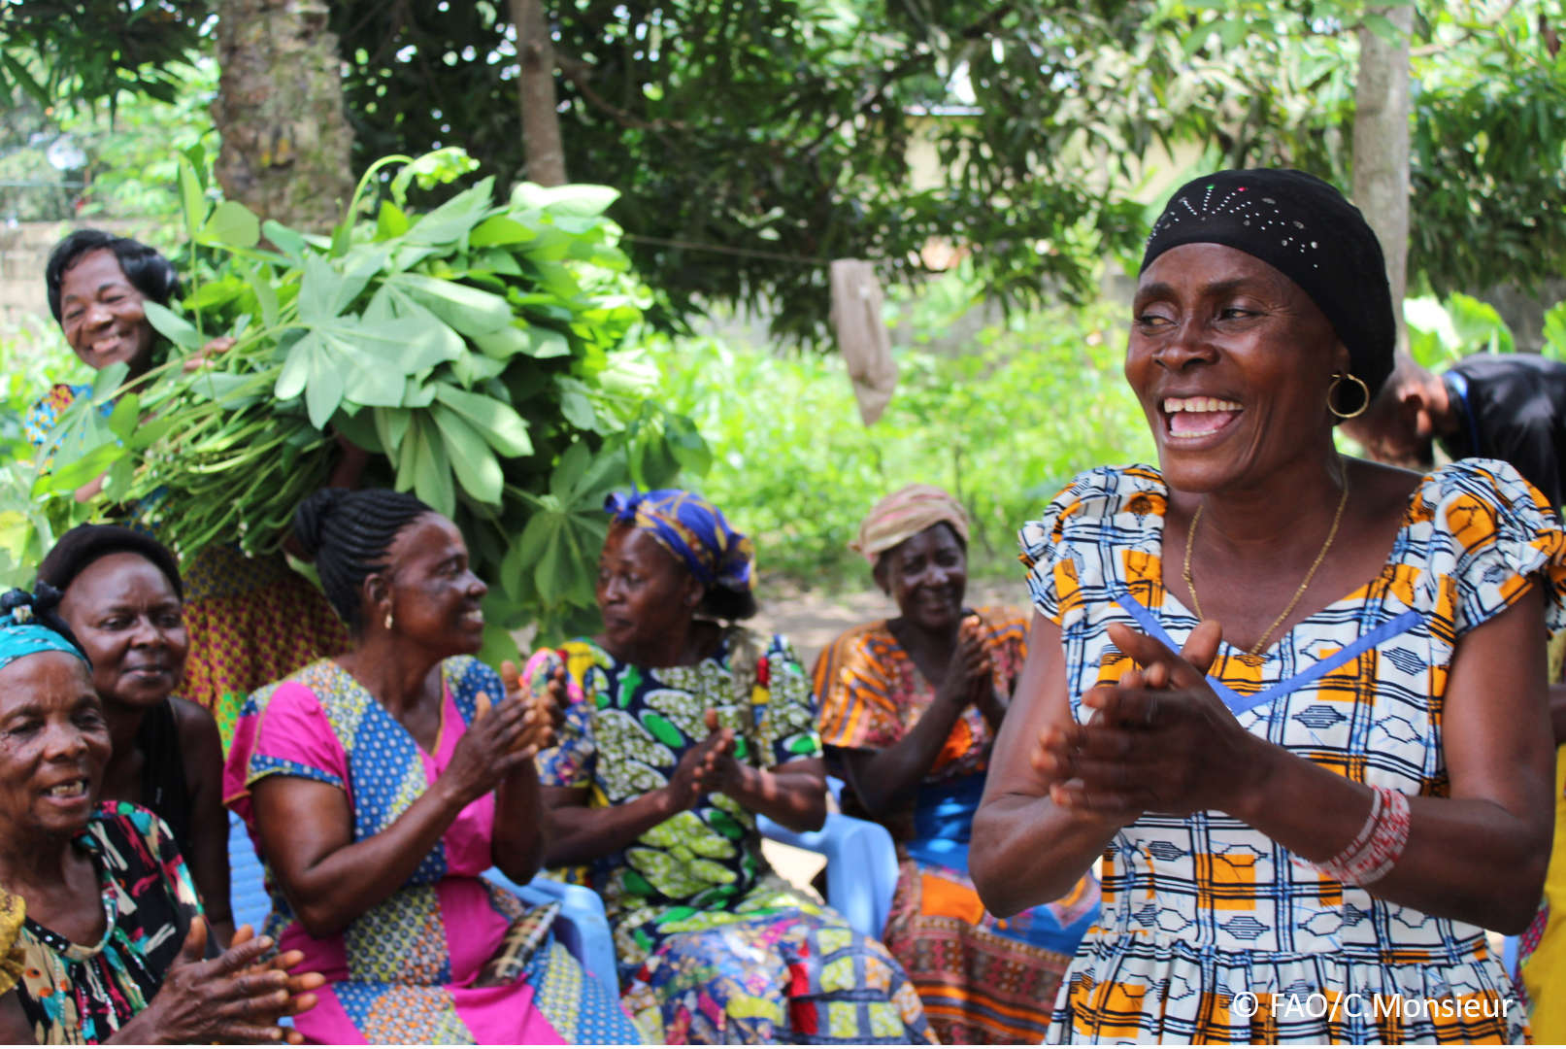
The objective of this call for submissions is to collect good practices, experiences, and lessons learnt on the use of community engagement for inclusive rural transformation and gender equality. The initiative, organized by the Rural Transformation and Gender Equality Division (ESP), seeks to gather insights from a diverse range of contributors, both within FAO and from external stakeholders. Its goal is to share knowledge, foster learning, and guide the scaling up of community engagement and community-led collective action to leave no one behind. The call builds on FAO's past efforts in this area, such as the Community Engagement Days series of webinars.
The call for submissions is open until 27 November 2024.

How to take part in this call for submissions:
To take part in this Call for submissions, register to the FSN Forum, if you are not yet a member, or “sign in” to your account. Please review the topic note to understand the criteria we are considering for this call. If you wish to learn more about community engagement, you may refer to the background document. Once you have completed this submission template, upload it in the box “Post your contribution” on the call webpage, or, alternatively, send it to fsn-moderator@fao.org.
Please keep the length of submissions limited to 1,500 words and feel also free to attach relevant supporting materials.
Para participar desta chamada para inscrições, registre-se no Fórum da FSN, se você ainda não for membro, ou "faça login" em sua conta. Por favor, revise a nota temática para entender os critérios que estamos considerando para esta chamada. Se você deseja saber mais sobre o envolvimento da comunidade, consulte o documento de referência. Depois de preencher este modelo de envio, carregue-o na caixa "Publique sua contribuição" na página da chamada ou, alternativamente, envie-o para fsn-moderator@fao.org.
Por favor, mantenha o comprimento das submissões limitado a 1.500 palavras e sinta-se à vontade para anexar materiais de apoio relevantes.

Template for submissions

Contact person: | Name: Teresa Paula Bernardo Ferreira  Organization/Unit: CEDES- Comite Ecumenico para o Desenvolvimento Social  Country: M ozambique  Email address: cedes.secretaria@gmail.com
Name/title of the good practice | Desenvolvimento comunitário liderado pela comunidade
Where is the good practice taking place? (Multiple selection allowed) | ☐ Europe and Central Asia  ☐ Latin America and the Caribbean  ☐ North Africa and Near East  ☒ Sub-Saharan Africa  ☐ Asia and the Pacific  ☐ North America  ☒ Global
Affiliation | ☒ Farmer and producer organizations  ☐ Trade Union  ☒ Informal community-based, farmer-based or self-help group  ☐ Research and academia  ☐ Government  ☒ Local/traditional authorities  ☐ Private Sector  ☒ Civil Society Organization  ☐ Intergovernmental Organization (e.g. UN system, World Bank)  ☒ Resource Partner/Donor  ☐ Other (please specify)
In which sector(s) and context (s) have you used this community engagement good practice? (Multiple selections allowed) | ☐ Education  ☐ Health and Sanitation  ☒ Food production in agrifood systems (please also tick the sub-categories)  ☒ Crop cultivation  ☐ Fisheries and aquaculture production  ☐ Livestock  ☐ Forestry  ☒ Agroforestry  ☒ Horticulture  ☒ Apiculture (beekeeping)  ☒ Agroecology and sustainable farming practices  ☒ Soil and water management  ☐ Other: ____________  ☒ Post-production in agrifood systems (please also tick the sub-categories)  ☒ Processing and value addition  ☒ Marketing and retailing  ☒ Transporting  ☒ Food loss and waste  ☐ Packaging  ☒ Storage  ☒ Distribution  ☐ Other _________  ☒ Gender Equality  ☒ Climate Action  ☒ Citizenship and Governance  ☒ Social Protection  ☒ Humanitarian and protracted crisis  ☒ Conflict resolution, peace and resilience  ☐ Digital innovation  ☐ Other sector (please specify) _________
Who are the financial partners supporting this good practice, if applicable? | Misereor, Pão para o Mundo, Tearfund. WWF, Diakonie, , UNHCR, WFP, USAID, INGD e UDSAID e CESVITEM
- In a few sentences, summarize your community engagement good practice.
1 Communities engaged in good conservation agriculture practices by doing environmentally friendly agriculture
2 Communities engaged in the construction of sustainable water supply sources, in the conservation and use of water, through the reuse of waste for irrigation as well as evaporation reduction measures in agricultural activities.
3 Community engaged in the sustainable use and use of available natural resources to create alternative sources of life as means of subsistence.
4 Communities engaged in savings and small businesses, as a way to expand the commercial network and interpersonal exchanges, generating money for basic needs as well as a bank to finance agricultural activities and the construction and repair of water sources for consumption and irrigation.
- What problem(s) or challenge(s) does your good practice aim to address through community engagement?
1Conservation agriculture aims to adapt, mitigate and respond to the challenges posed by climate change in agriculture and food production, protect soil from erosion, improve soil fertility, protect the environment, improve social sustainability, conserve biodiversity as well as reduce deforestation.
2. With the construction and conservation of water supply sources, it is intended to develop habits and practices of using the necessary water, conserve and preserve water supply sources, reduce waste to a minimum, as this liquid is very useful for human and animal consumption, for agriculture, industry and for environmental balance.
3. The use of natural resources in a sustainable way has helped communities to diversify sources of income, contributed to the improvement of the diet and the availability of raw materials for the production of objects of adornment, domestic use, creating income for the communities.
- Describe your good practice in more detail. Include the main guiding principles, the desired changes or outcomes you aim to achieve (Theory of Change), and the key phases of implementation.
Agricultural production is based on organic and ecological production techniques, preserving a sustainable environmental balance, through practices that avoid the use of pesticides and indiscriminate felling of trees, burning, preservation of micro fauna, conservation of rivers and other locally available natural and artificial water sources, for the benefit of increased agricultural production and productivity, that contributes to the improvement of the communities' diet and financial conditions through the commercialization of surpluses. In addition, this type of agriculture preserves the environment by protecting soils from erosion and often improving soil fertility and biodiversity.
Sustainable use of locally available resources for the diversification of income sources through the promotion of beekeeping, handicrafts and ceramics and other activities contributes to the preservation of them. These are used in order not to destroy the ecological and environmental balance of the extraction sites as well as in the defense of endangered species.

Improving the management of community finances through the creation of savings groups, revolving finance, and small businesses, capitalizes community members, thereby creating community capacity to finance various alternative income-generating activities including agriculture, livestock, construction, repair, and maintenance of water supply sources. Savings and small businesses also serve as community banks to finance agriculture through the purchase of inputs and accessories to repair water supply sources.
- Who are the key actors and stakeholders involved in the design and implementation of the good practice, and what are their respective roles? Consider local partners, government, local authorities, community radios, civil society, research, the private sector, etc.

The key actors and stakeholders in good practice are:
1- Local communities are the key actors in the identification, prioritization and implementation of any type of activities described above. They are involved in the design, initial data collection, implementation and monitoring. Then, they are the same ones who benefit from the results of these initiatives and expand the practices and achievements to other communities, which bring positive changes.
2- Community leaders serve as a gateway to engage with the community and play the mobilization and support in the implementation of good practices.
3- Local Church through the local Ecumenical Committee serves as a link between Community-Church and EDES, in the community mobilization for positive changes and also as a mechanism for complaints, complaints and suggestions as well as advice.
4- Local government responsible for verifying compliance with sectoral policies and providing support for achievements, supporting and witnessing positive results.
5- Local partners contribute with ideas so that there is no duplication of initiatives in the same communities.
6- Private sector, mainly the commercial sector, serves as suppliers of inputs and materials for use to make initiatives a reality.
- How does your intervention ensure inclusivity and equal and meaningful participation within the community?
Describe how your intervention includes and engages different groups within the community. Consider aspects like gender, age, ethnicity, disability status, livelihoods, and other specific conditions (e.g., people living in prolonged crisis, migrants, refugees). Explain how your intervention engages diverse segments of the rural community. Highlight the specific actions or strategies you use to reach these groups. If applicable, mention if your intervention uses specific approaches such as gender-responsive, gender-transformative, intersectionality, or other methods to ensure inclusivity and gender equality.
- The internal policies clearly describe how the selection of beneficiaries should be made and how the different groups of the community should be included, privileging the participation of the female head of the family in more than 50%, children heads of families, heads of families welcoming orphaned children, those with chronic diseases or substitute families, people with the level of proven vulnerability, the physically disabled as well as those interested in being part of it. For people with less productive capacity, the communities initiatives have created a spirit of mutual aid in the production work and in the sale of surpluses, allowing everyone to be included without distinction of sex, ethnicity, religion and others. These policies are used in all kinds of responses, both in development and in emergencies.

- By using community engagement, what results and impacts have your good practice achieved?
- Communities Involved and Use Conservation Agriculture Techniques;
- Communities involved produce food all year round;
- Communities involved have improved and diversified their diet due to the practice of conservation agriculture;
- People in the middle of the community have improved their living conditions and sanitation in the environment;
- Woman's with time to rest because she has water closer to her;
- More girls on the school bench because the water is closer to families;
- More children on the school bench as parents pay the fees;
- Fewer social conflicts because communities have the minimum for survival;
- More communion with God because people pay tithes and contributions in the Churches;
Please provide specific examples and evidence demonstrating the effectiveness of your
intervention, focusing on both qualitative and quantitative outcomes related to livelihoods and well-being improvements.
Associative groups of agricultural production in number of 36 with 935 participants of these 789 are women working in an area of about 1000 ha for rainfed and horticulture.
In savings and small businesses, 40 associative groups with about 1134 beneficiaries, of which 835 are women, develop this activity, of these, 80% practice small business, purchase and sale of basic necessities, commercial exchanges between communities, and in the last closure of savings yielded 8,789,372.00 Mt
In beekeeping, the participation of women is prioritized and promoted, for this purpose, they are trained in techniques for building beehives, managing apiaries, collecting, processing and selling honey. At the moment there are 120 people practicing beekeeping, of which 43 are women, and the number tends to rise. About 500 liters of honey was harvested, processed and sold.
- Among these results, has the good practice led to improvements in terms of gender equality, women’s empowerment, and/or social inclusion?
In agriculture, the practice of this activity is more carried out by women and girls, and they are more empowered, but with intervention and mobilization there begins to be considerable male adherence.
In savings and small businesses, women are more empowered, but the low participation of men for cultural reasons continues because men are always expecting to someday move to other provinces in search of employment, while in women the possibility is little due to the care they have for their children.
A juventude participa nas actividades e são empoderadas e esta faz muita diferença pois estes têm alguma literacia
The leaders of the groups are largely women because they constitute the majority of the beneficiaries, their partner, the man, also performs the leadership functions.
Describe the behavioral changes in terms of gender that the good practice promotes, emphasizing agency, leadership, and participation in local governance. Include efforts to challenge discriminatory norms and unequal power dynamics. Highlight also how the intervention has supported the well-being (including psychological resilience) of marginalized groups and enhanced their inclusion and participation in decision-making processes.

The change in behavior in relation to the previously inferior position of women has changed drastically because women already perform activities that were traditionally reserved for men, such as beekeeping, reserved for men because hives were placed on top of trees, which made it difficult for women to participate, today they are placed at a working height in a standing position, Women participate, governance, women could not play a leadership role especially when there are men, but today they already do it, having a say in a meeting before men, nowadays things have changed. It was not easy to change for men even for women, but training played an important role.
- What key challenges did you encounter while implementing the community engagement activities, and how did you address them?

1 Cultural barriers - Women have been educated as inferior beings to men and who cannot speak to men, with training this barrier has been overcome
2 Jobs reserved only for men - We find beekeeping, part of handicrafts as activities reserved for men, with training was surpassed
3 Agriculture reserved for women because men go to work in companies - Nowadays there are no companies to house a large number of men, they are being sensitized to work the land, and they see the results in other men, although in a timid way, but there are positive changes
4. Low participation of girls in school - With the availability of food and water sources close to families, girls already go to school in considerable numbers. Include any resistance from communities, pushback, or issues related to unequal power dynamics, if applicable.
- What are the key lesson learned from your community engagement good practice?
1 Community engagement must begin with community mobilization.
2. Community leaders should be explained in detail how engagement should be done
3. The selection criteria and legible criteria must be clearly explained to the participants and leaders before the start of the intervention
4. Seats should be reserved for proven disabled and vulnerable people even if they were not present at the enlistment ceremony, because they do not participate in the meetings because they feel previously excluded.
- Has this practice been replicated in the same context or in different contexts?
What are the required conditions to replicate and adapt the practice in another context/geographical area?
- This practice is applied and replicated in all contexts, both development and emergency
- What are the necessary conditions to replicate and adapt the practice in another context/geographical area?
The conditions are related to the existence of the need for an intervention, and these are based on the universal standards contained in the project spheres on humanitarian and development interventions. Nothing to invent but to use universal norms.
- How sustainable are the results achieved by this good practice?
Describe the key elements that need to be in place to make the initiative sustainable, including enabling environment (legal and policy frameworks and institutions), local ownership, accountability, etc.
To make the community development initiative sustainable, it is necessary to:
1 Have a vision and a plan of activities.
2 Continue to maintain partnership and community participation in the initiative as two key alliances,
3 Continue to ensure that the development process and initiative is owned and managed by the local community itself, not dependent on external aid.
4 That communities continue to take ownership of the initiative, taking into account the local situation and resources
5 That community and local church leaders be part of the initiative, supporting, monitoring as well as facilitating lobbying for community interests
6 Always make inclusion to continue with the environment where all people feel valued, respected and able to contribute fully to the initiative and to the life of the family and the community.
- Based on the conversations FAO held during the Community Engagement days, a definition of community engagement for empowerment was proposed:
12. Com base nas conversas que a FAO realizou durante os dias de Engajamento Comunitário, foi proposta uma definição de engajamento comunitário para o empoderamento:
“Community engagement for empowerment and community-led collective action can be defined as an inclusive and participatory process that enables community members to become active agents of change in decisions affecting their lives, health, and environment. This process develops their capacity to achieve sustainable outcomes for improved rural livelihoods. Embracing a rights-based approach, it prioritizes the agency and participation of all community members, regardless of gender identity, sexual orientation, age, ethnicity, caste, socioeconomic status, political affiliation, migration status, or ability/disability. Indeed, inclusive approaches recognize the complexities of overlapping marginalization and discrimination that can exclude different community members from decision-making processes and implement strategies to foster their participation, agency and empowerment.”
“This involvement can also include building networks of support and solidarity among community members, identifying and overcoming challenges and obstacles together, and articulating with other communities and social movements in pursuit of common goals’’

- Based on your experience, what gaps or areas for improvement still need to be addressed in the field of community engagement?
1 Empowerment of the community on mitigation, adaptation and preparedness measures and actions for extreme events and environmental disasters that may include building sustainable water sources and multipurpose production fields to produce all year round without depending on rain
2 Empowerment of the Local Church on its role in preparing for, mitigating and responding to extreme climate change events and environmental disasters, improving its infrastructure to house people in case of need
3 Empowerment of Communities on the means of survival as a way to mitigate the effects of climate change, such as the production of handicrafts, beekeeping and others that help in environmental preservation
4. Train community leaders in natural resource management laws, land processing, and others related to community life
- What do you think is FAO's role in the field of community engagement? How can FAO support and enhance interventions like yours, if applicable? Consider aspects such as policy advocacy, capacity development, funding, technical assistance, knowledge production and sharing, and fostering partnerships.

1. Implement the government strategy to alleviate hunger, food insecurity and malnutrition and ensure the availability of adequate food for all inhabitants of the planet;

2. Making agriculture, forestry and fisheries more productive and sustainable To this end, it seeks to develop these sectors both to increase production and to prevent natural resources from running out;

3. Help countries implement poverty reduction programs and strategies based on evidence collected over the years;

4. Ensure more inclusive and efficient agricultural and food systems, aiming that all productive agents are included in the models that are emerging.

5. Increase the resilience of the disadvantaged to threats and crises, helping countries to discover the causes and help them prevent and mitigate crises involving hunger and malnutrition;

Link(s) to specific references about your good practice (e.g. reports, communication products, videos, articles) | https://www.picdrop.com/sebastianhaury/zD5SgMqUjd  www.cedes.org.mz

The call for submissions is directly aligned with the thematic components of collective action within FAO's Programme Priority Areas (PPAs), specifically Better Life 1 (Gender Equality and Rural Women’s Empowerment), Better Life 2 (Inclusive Rural Transformation) and Better Life 3 (Agriculture and Food Emergencies).

